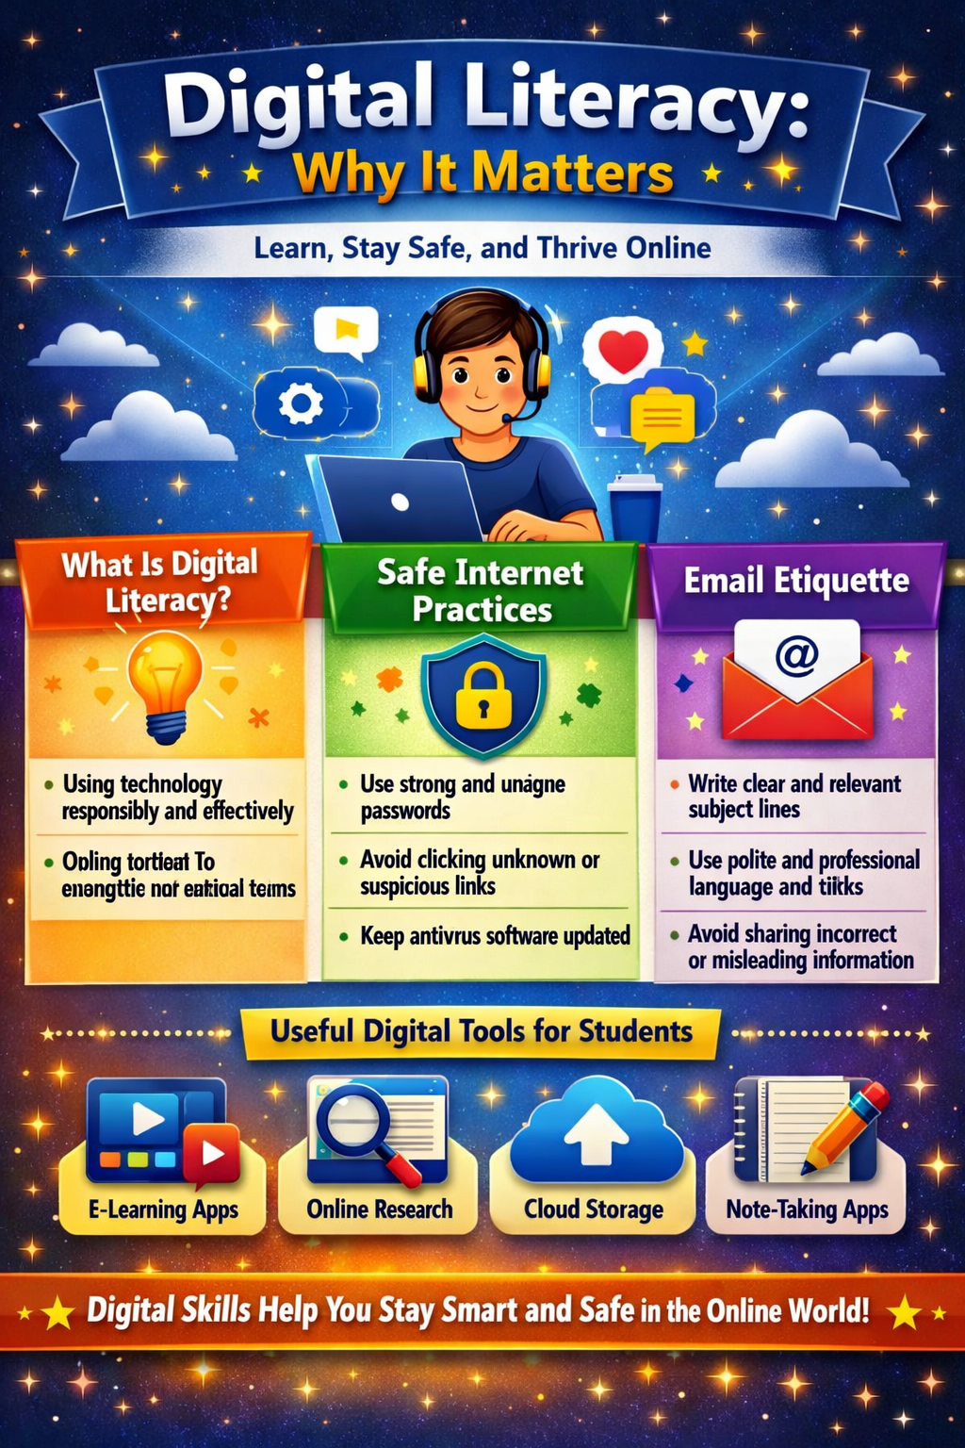
Tool Used:
I chose Canva as my design tool because it offers free templates, icons, and layouts that make infographic creation simple and visually appealing. Canva’s drag-and-drop interface allowed me to quickly arrange text and graphics without needing advanced design skills.
- Design Overview:
My infographic is titled “Digital Literacy: Why It Matters”. It covers four main topics from the assignment list:
What Digital Literacy Is – Defined as using technology responsibly and effectively, with emphasis on engaging in safe and meaningful online communication.
  - Safe Internet Practices – Highlighted through tips such as using strong passwords, avoiding suspicious links, and keeping antivirus software updated.
  - Email Etiquette – Focused on writing clear subject lines, using polite and professional language, and avoiding misleading information.
  - Useful Digital Tools for Students – Listed examples like e-learning apps, online research platforms, cloud storage, and note-taking apps.
Visual Elements:
I used icons such as laptops, locks, and email envelopes to represent each section. A central illustration of a student using a laptop ties the infographic together, symbolizing the learner’s digital journey. Bright colors and a clean layout were chosen to make the content engaging and easy to read for students.
- Interesting/Difficult Aspect:
One challenge I faced was balancing text and visuals. Initially, the slide looked overcrowded when I tried to include too much detail. I had to refine the content into concise bullet points while still keeping the message clear. On the other hand, I found it interesting to experiment with Canva’s templates and icon sets—this helped me understand how design choices can influence readability and engagement.
- Final Reflection:
Overall, the infographic communicates the importance of digital literacy by combining practical tips with appealing visuals. It encourages students to stay safe, professional, and effective in the online world.

